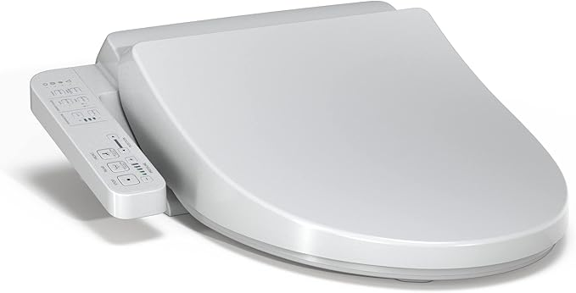

$271

TOTO WASHLET A2 Electronic Bidet Toilet Seat with Heated Seat and SoftClose Lid, Elongated, Cotton White - SW3004#01